Details of your portfolio
PD URL site (*Compulsory to fill up for milestone 2 and 3):
Live link/URL of your PD site

Name of your portfolio:
Kaera Barber’s portfolio

Your Logo:


Describe your target audience:
My target audience for this website are future employers, industry professionals and potential collaborators in the industry that I am studying in which is design and development. The age range of the target audience is around 20-45 years old, are likely based in Singapore and value innovation, aesthetics and purpose-driven design. They are usually involved in fields like graphic design, UI/UX and programming and are looking for emerging designers who can bring fresh ideas to the table.

Describe your brand story/ purpose:
I am a student studying digital design and development, passionate about creating meaningful and visually engaging designs. My interest in design began with a love of creating and storytelling and it has evolved into a deeper interest and understanding on how different elements and components work together to send a message. My goal is to present myself as a thoughtful and versatile designer that resonates with my target audience.

Design brief
Colour scheme & Colour palette:
I have decided on a monochromatic colour scheme which includes shades of brown with small pops of brighter colours to help draw attention to important points of the website.
Here is a base colour scheme:
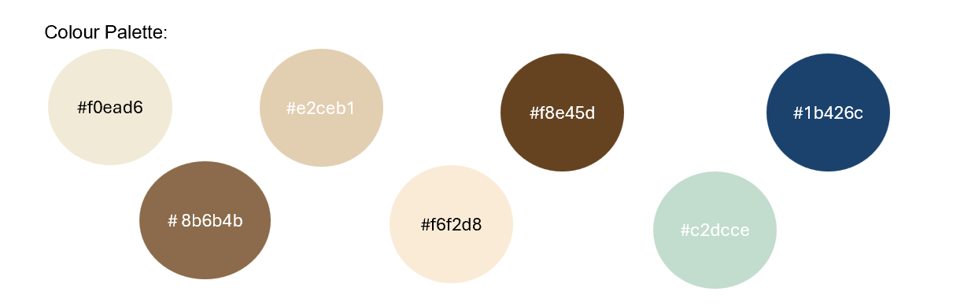

Typography:
Montserrat
Open Sans

Theme:
Minimalistic scrapbooking

Layout/ Arrangement:
Opening page

Home
About
Contact
Portfolio

Development work
Design work

Low fidelity wireframe:
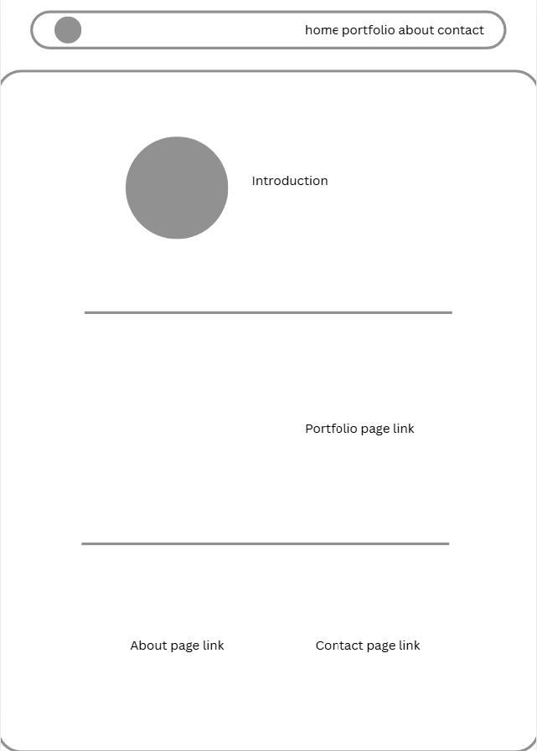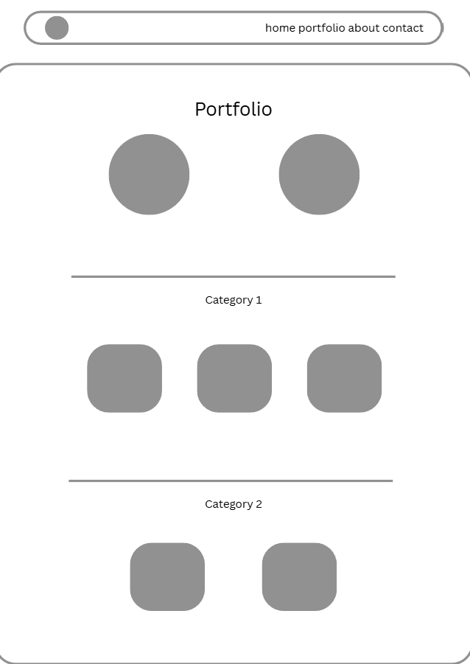
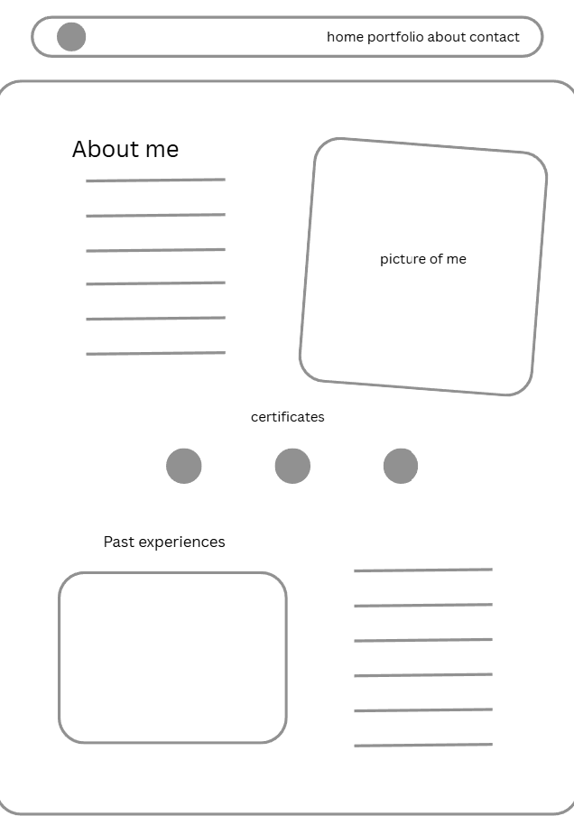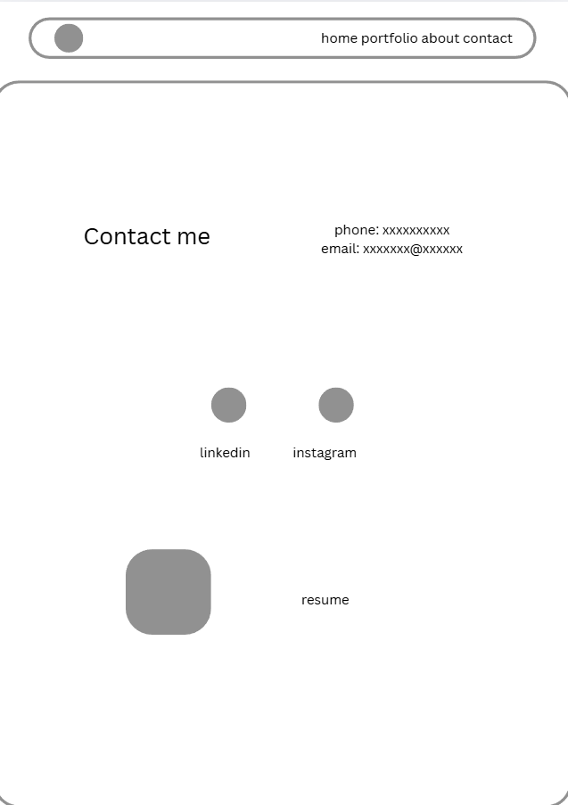
High fidelity wireframe (*Compulsory to fill up for milestone 2 and 3):
Insert your high-fidelity wireframe here. Full set of ALL the pages in JPEG or PDF format.
E.g.

Link to your Prototype – Most likely on Figma (make sure your lecturer is given access to the site) (To fill up for milestone 2 and 3):
Insert your Prototype link here (most likely on Figma)

